**Attach volume to windows EC2 instance**

1. **Create the windows ec2 instance**

* Create the new EC2 instance and in AMI search for windows and select the free tier eligible
* In auto assign give it as public
* In security group it will RDP will be there
* 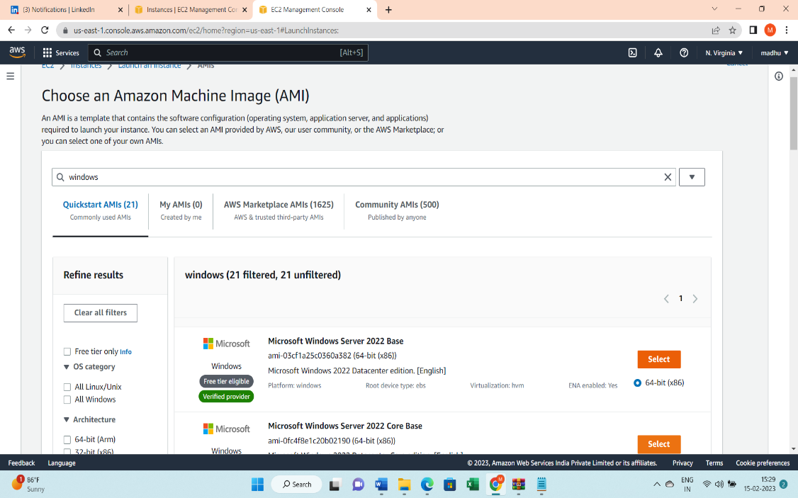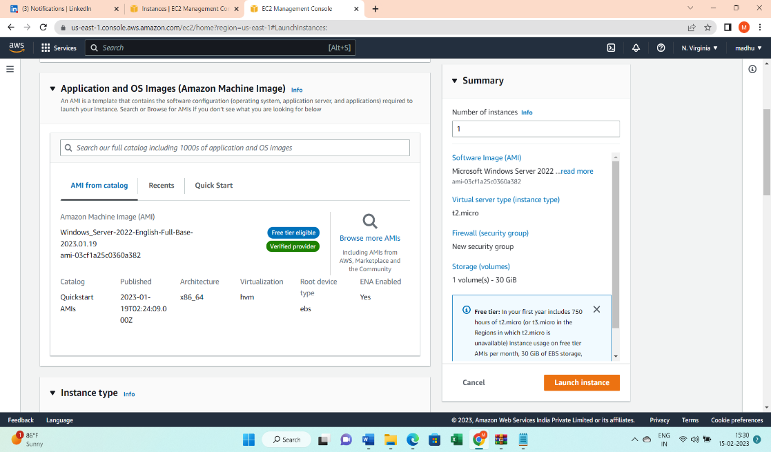Keep a track of the availability zone because we have to create the volume also in same availability zone .The EC2 instance and the volume should be in the same availability zone .
* Now to connect to the instance ,select the ec2 instance and click on “connect” .
* 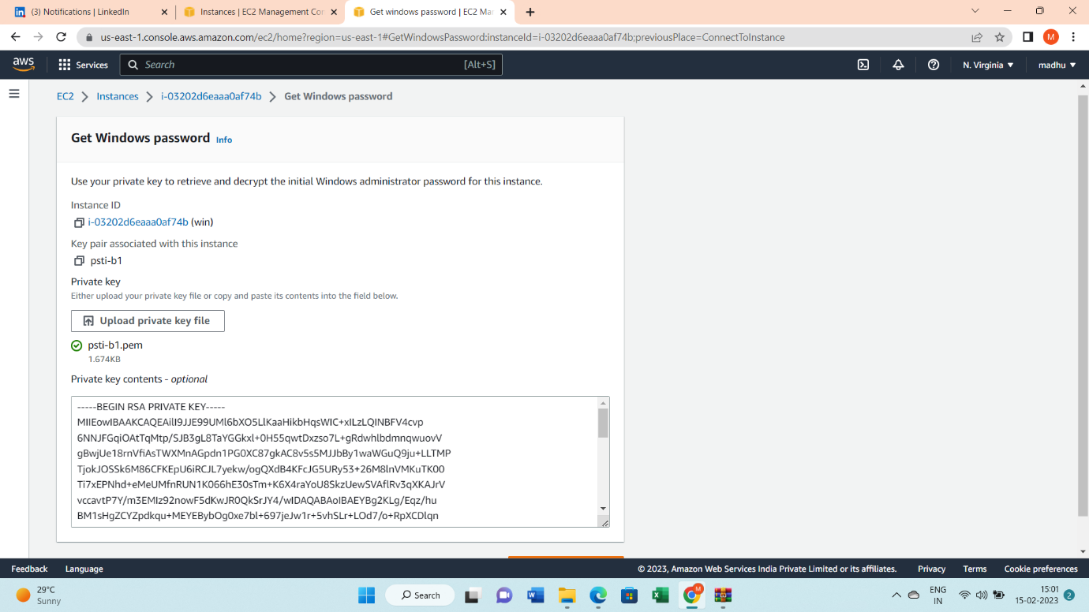In connect to instance ,select RDP client and click on “get password”
* 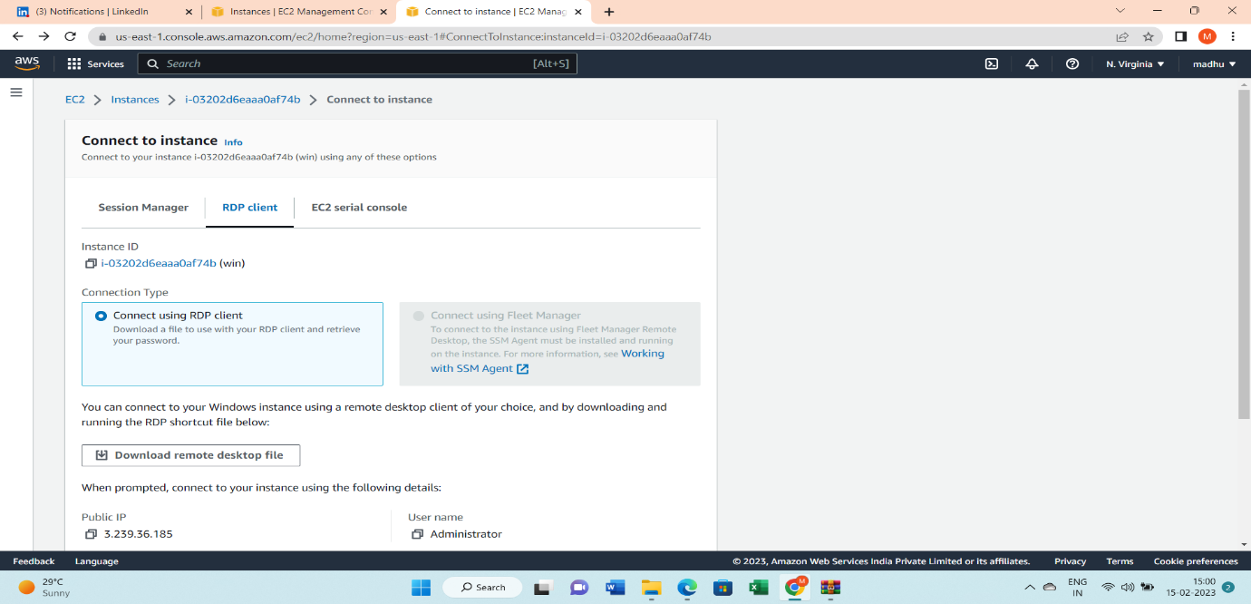upload the private key or copy paste the private key and click on decrypt the key ,then the password will be generated ,copy the password.
* Download the remote desktop file and click on open.

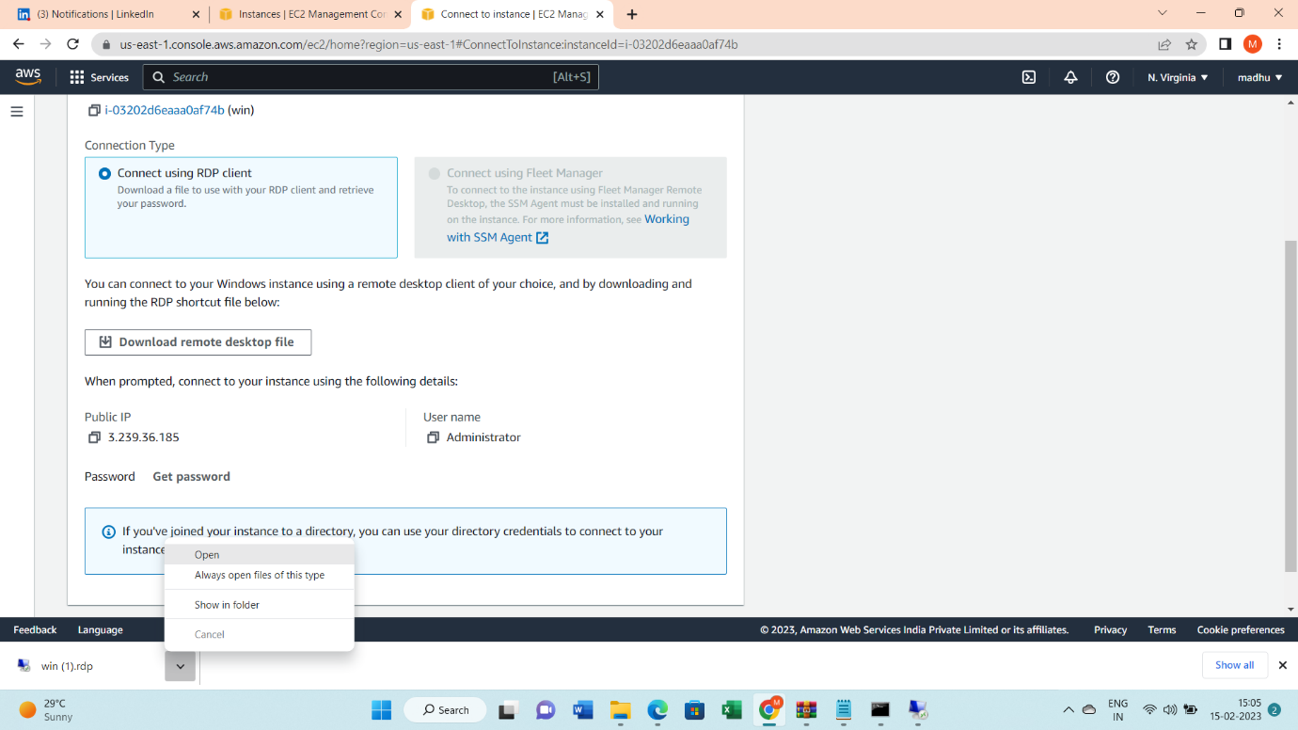

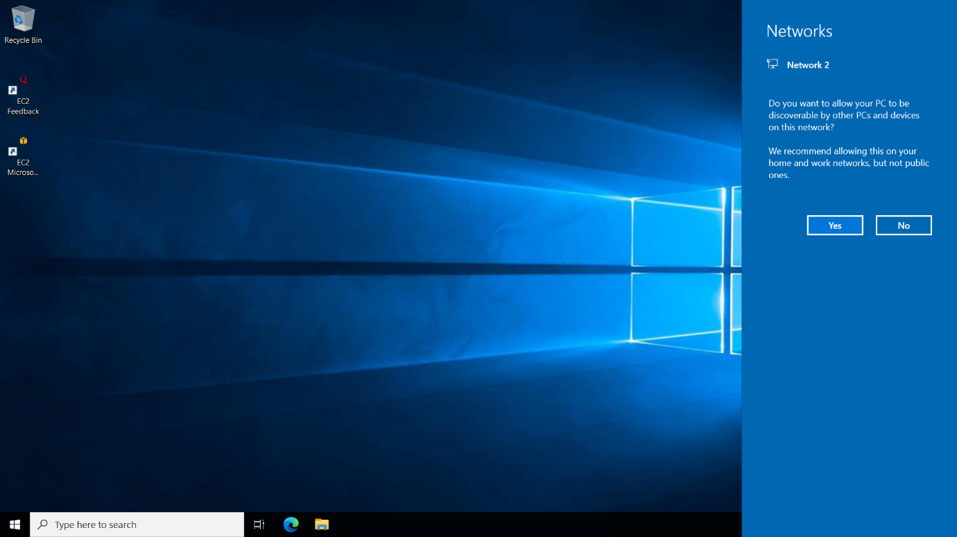

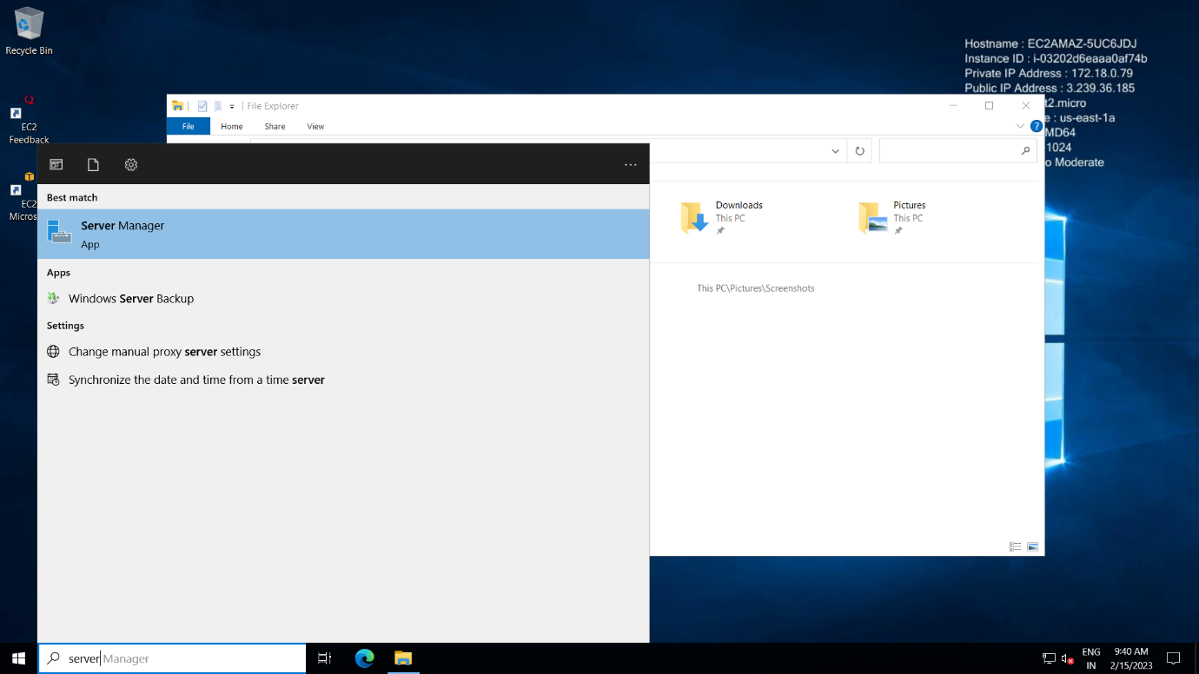In search bar, search for “server manager”

* Click on “file and storage services”

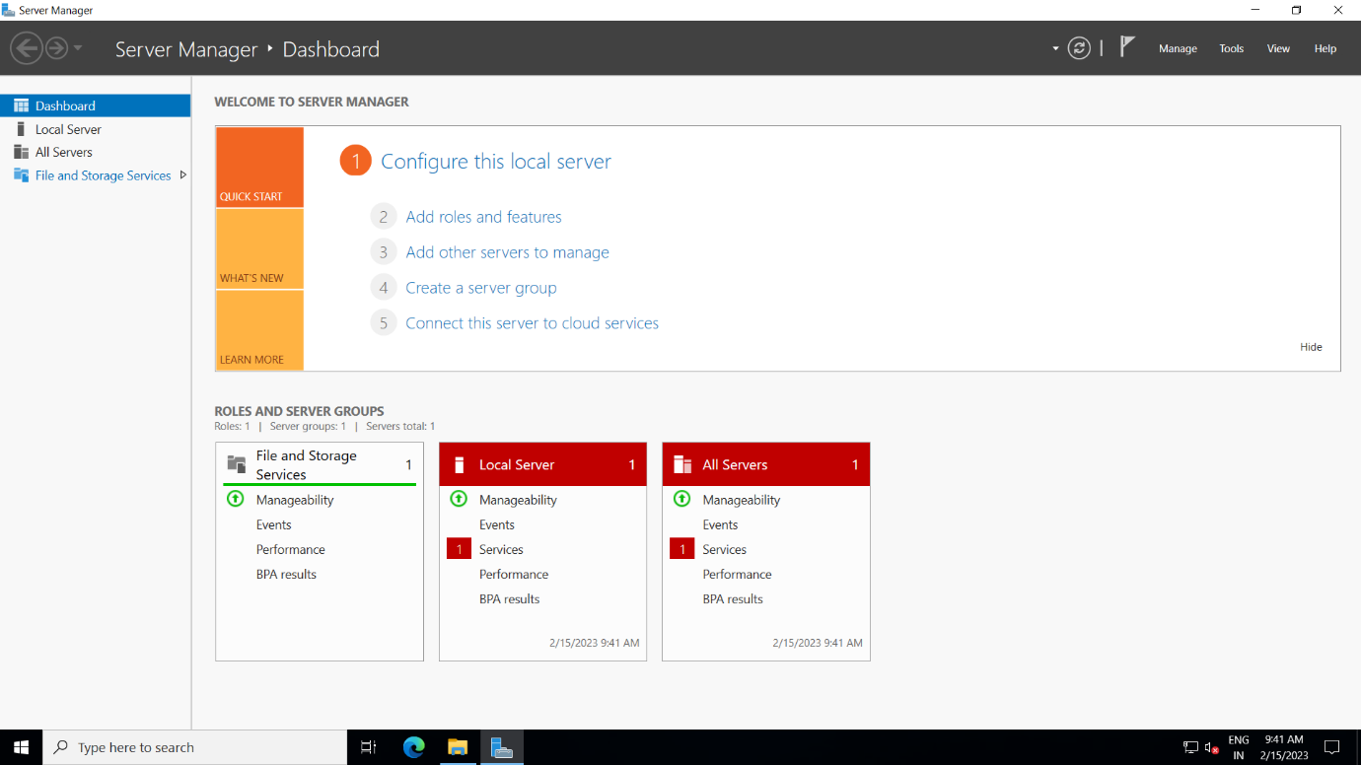

* 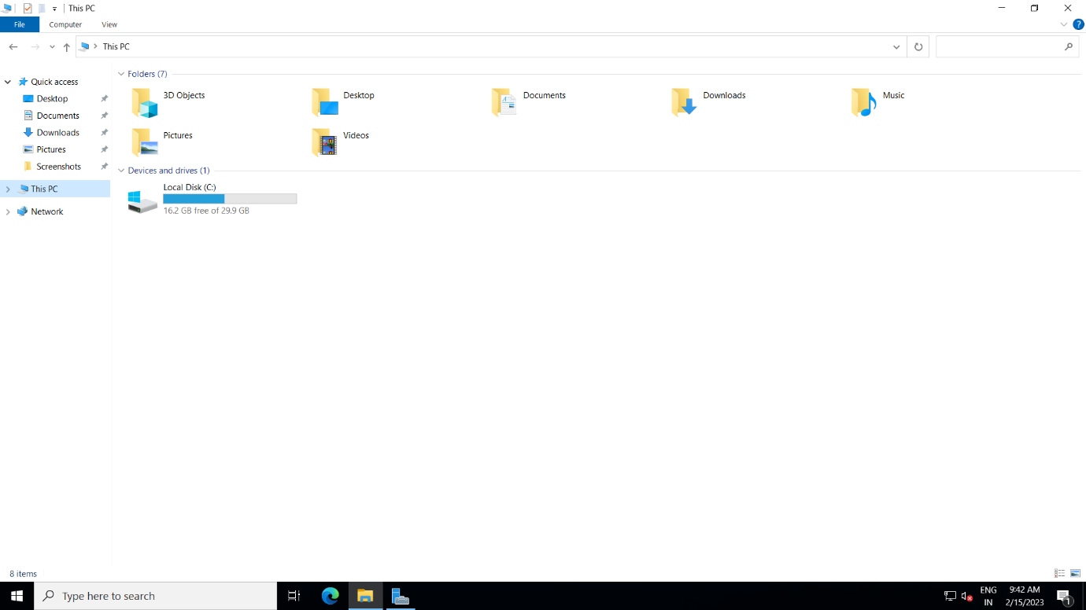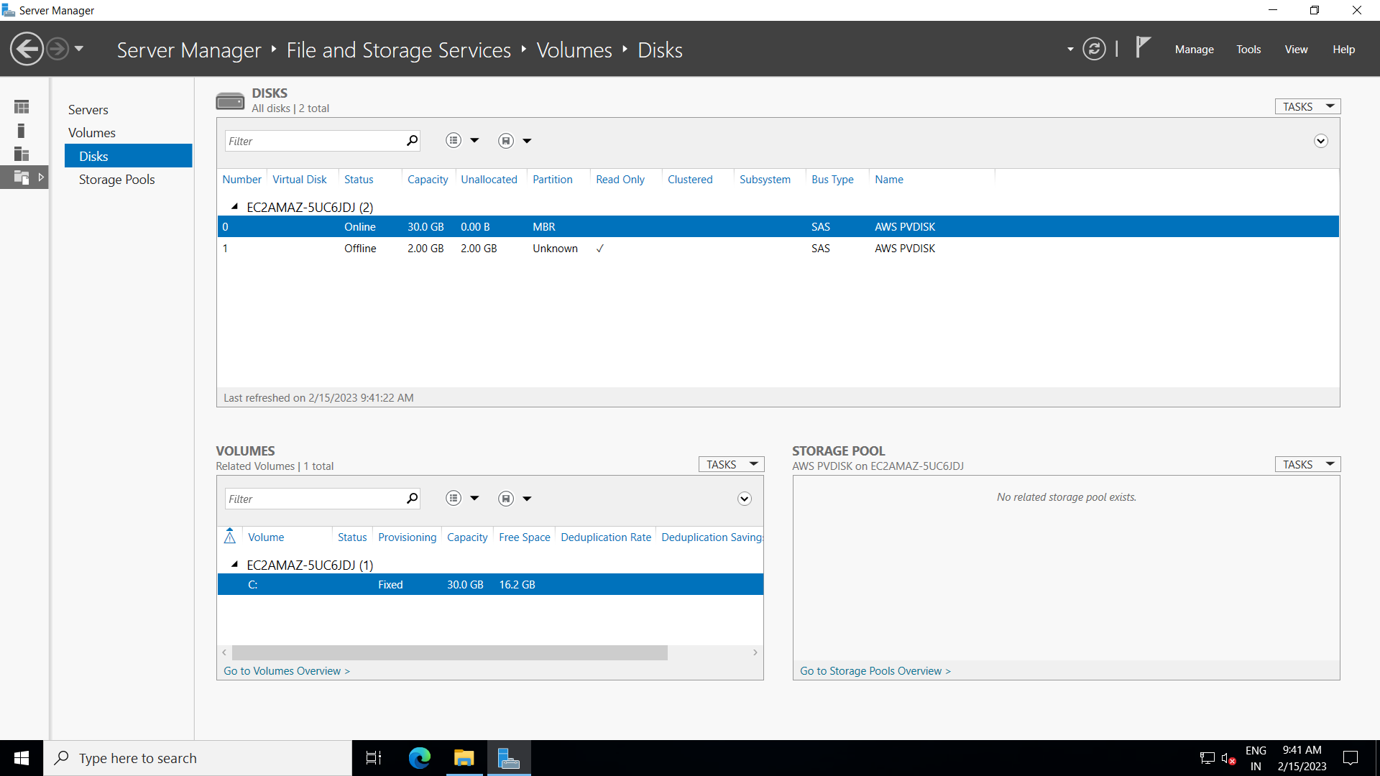click on disks after that we can see only 30gb disk (note : here its two because I have already created volume but usually its one and I have not made it online its offline yet so in the below image its not yet visible)

1. Create & Attach the volume to the Windows EC2 instance from the AWS console.

* In EC2 dashboard ,

1. select volumes
2. click on create volume and give the size as 2 gb and make sure the EC2 instance and volumes are in the same availability zone and then
3. 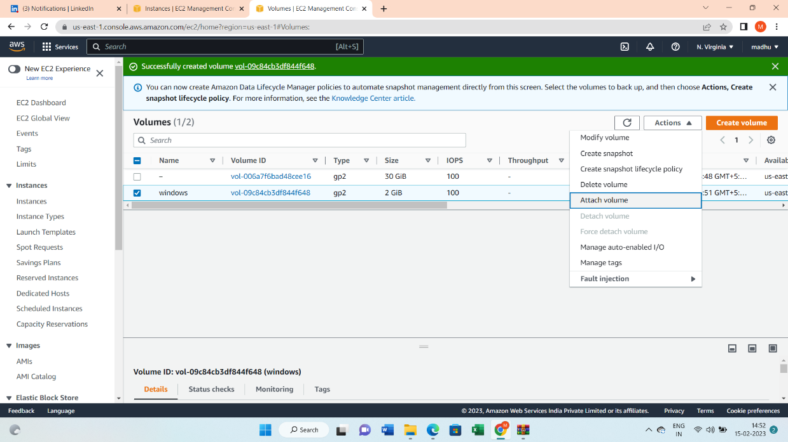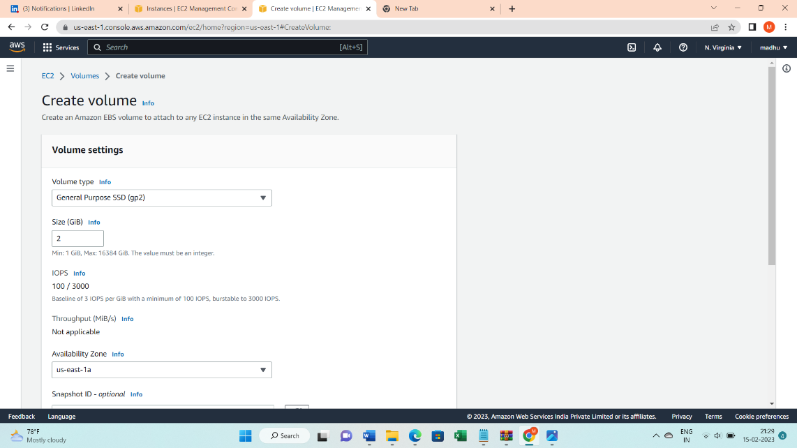 click on create.

* Now we have to attach the volume to the Instance so ,

1. click on actions
2. select attach volume now
3. select the instance
4. 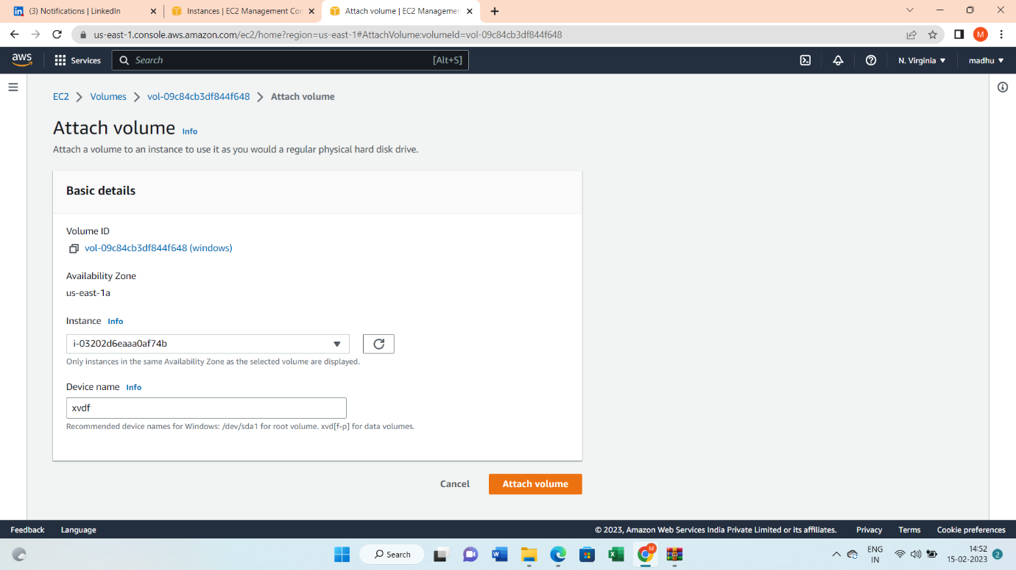click on attach volume.

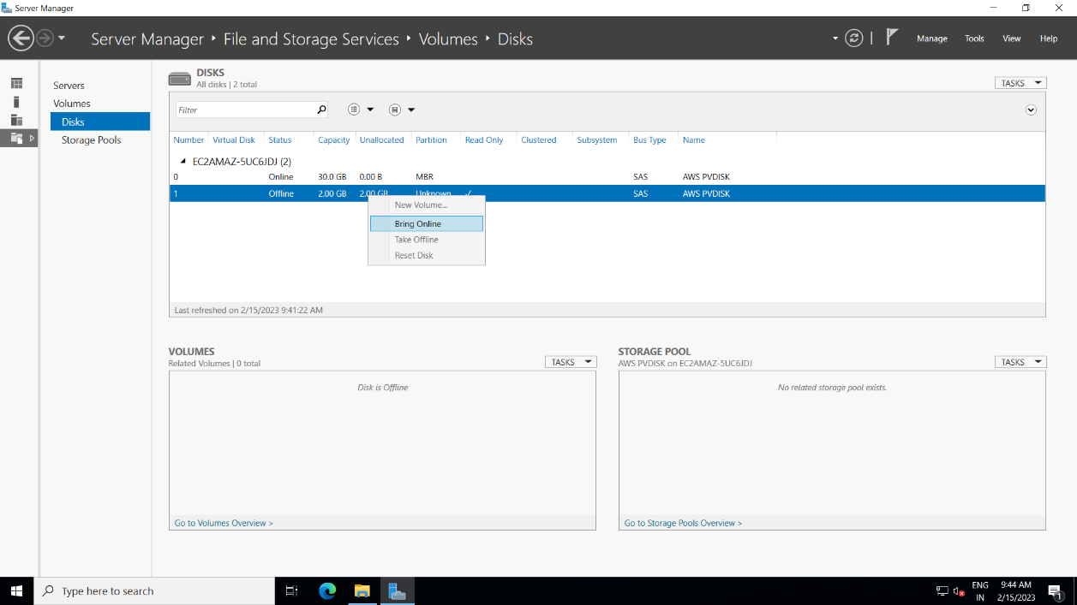3. Format the volume inside the windows EC2 Machine

* 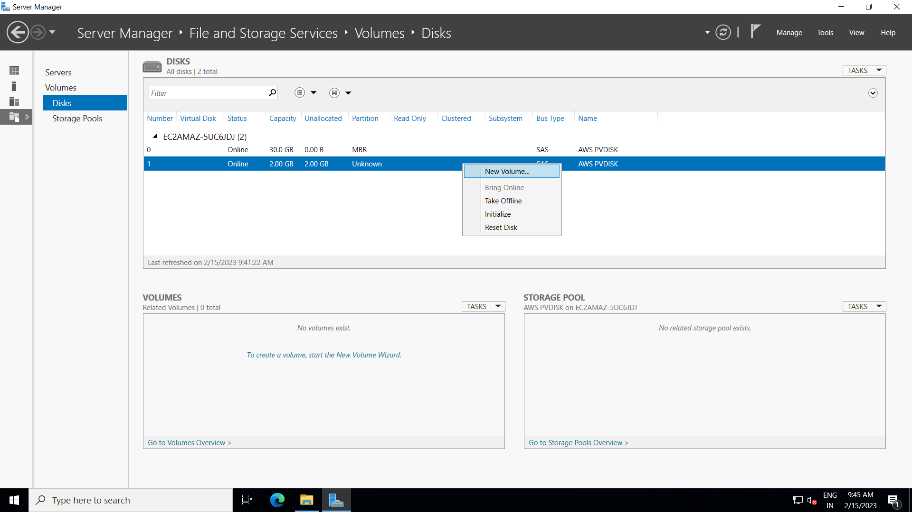Now select the 2gb volume and bring it online by right clicking on it and click on bring online
* 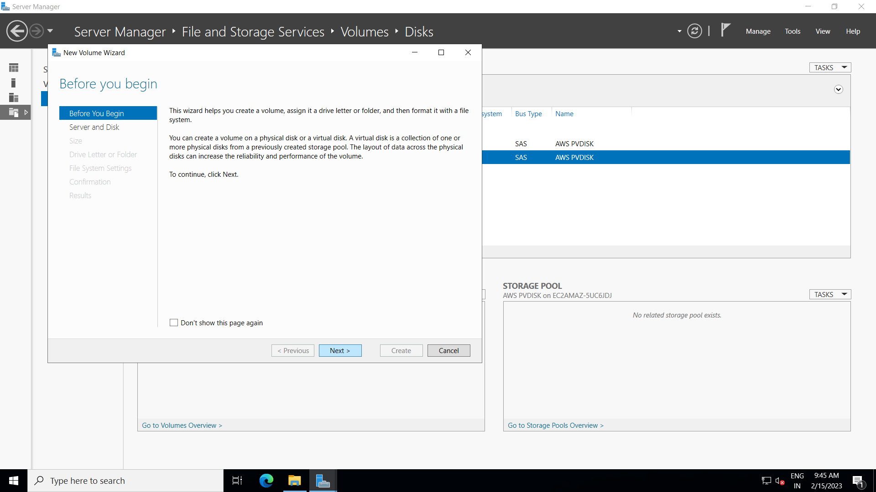Now again click on 2 gb volume and right click on it and select new volume after that keep selecting next and click ok.

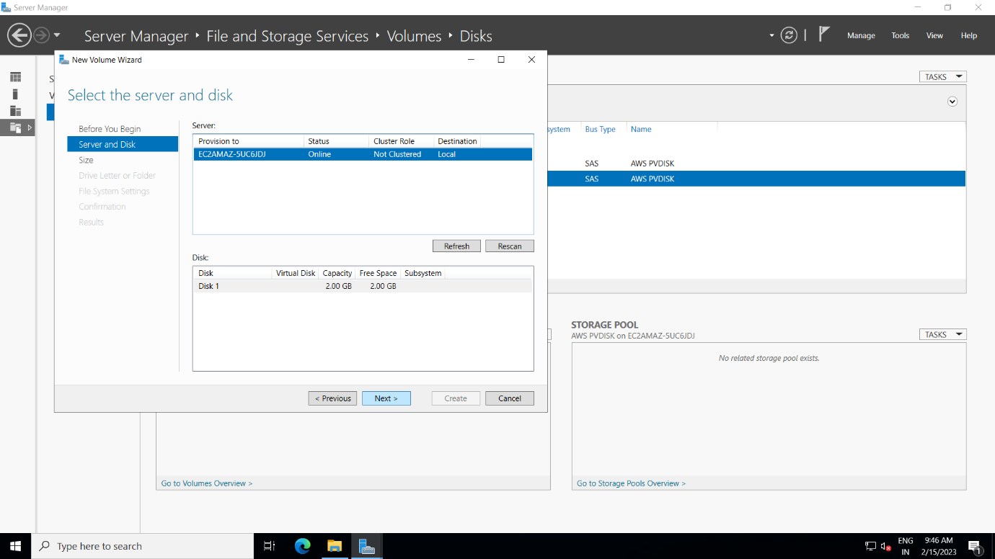

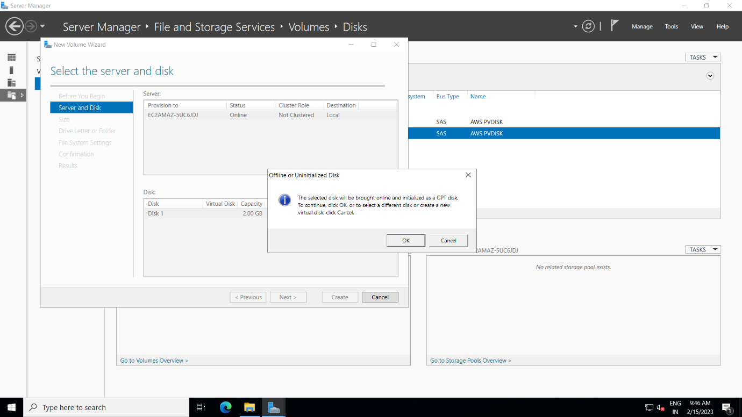

* 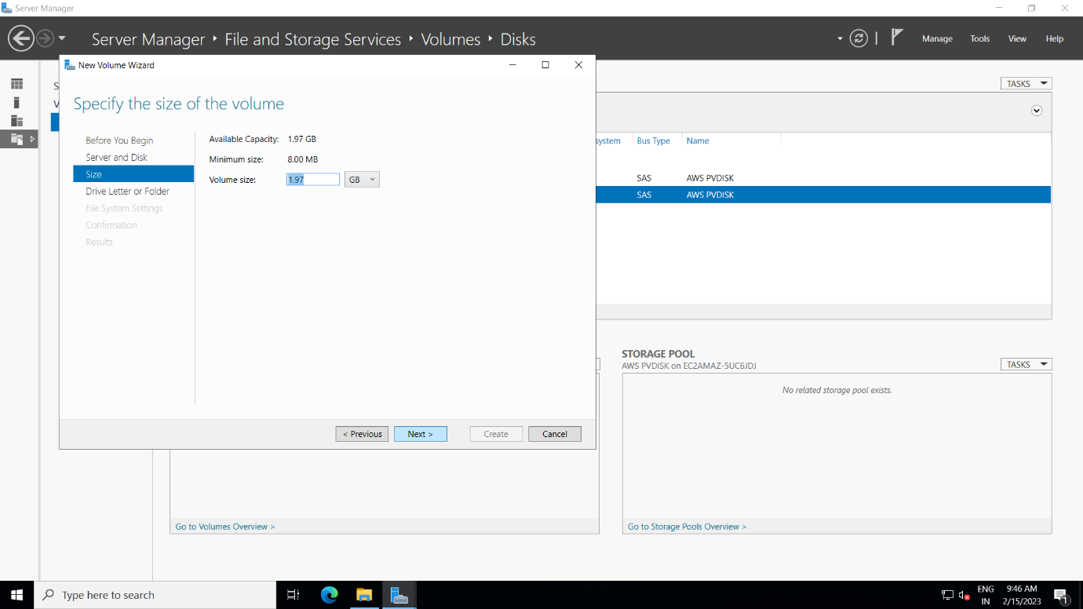 After giving “ok” give the volume size and select next

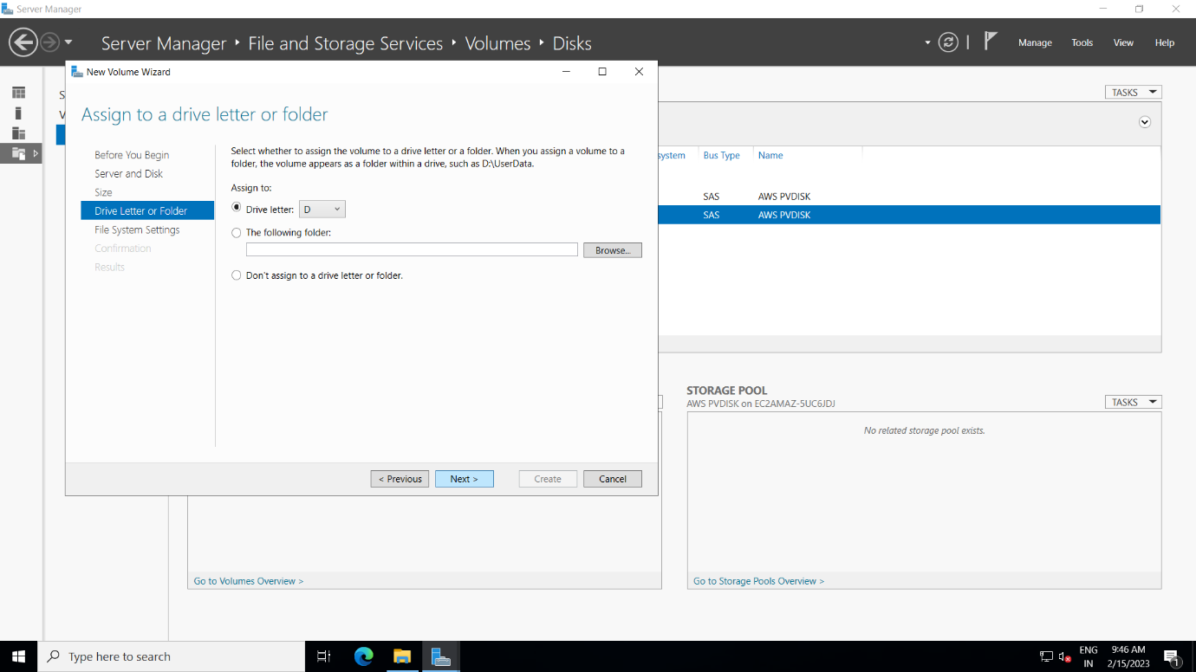

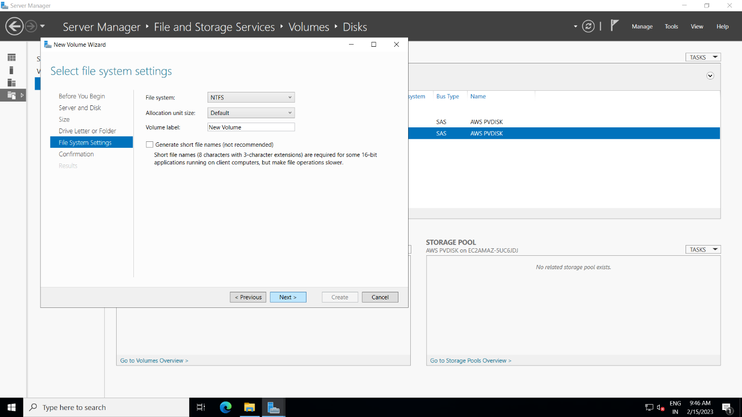

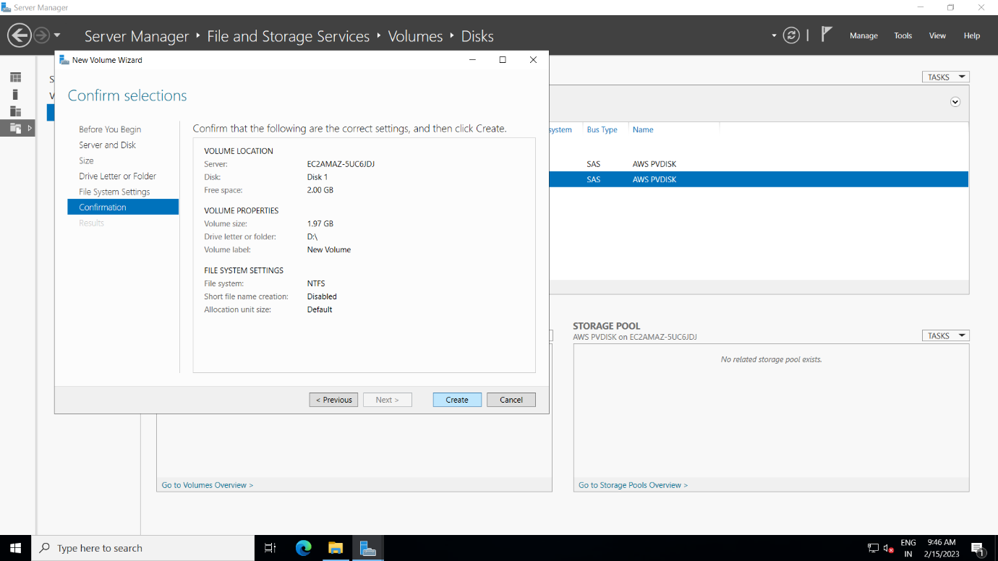

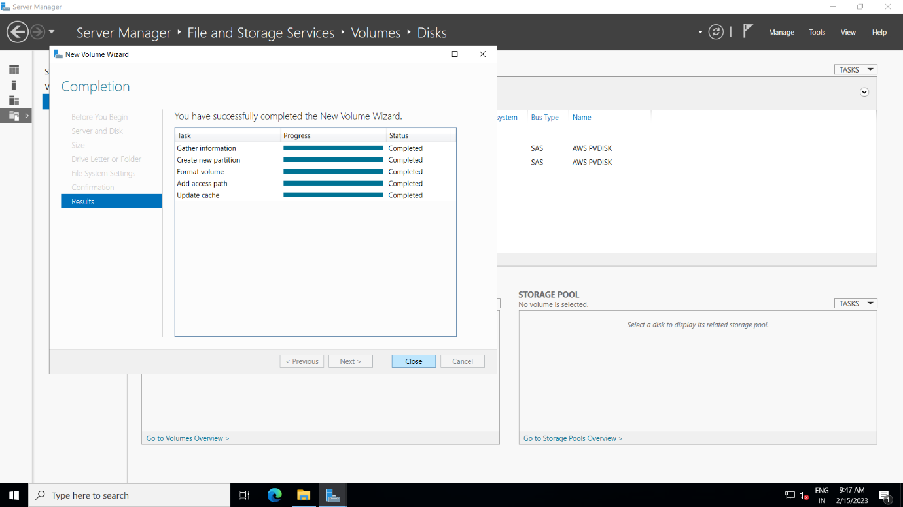

Now we can see the new volume is been created

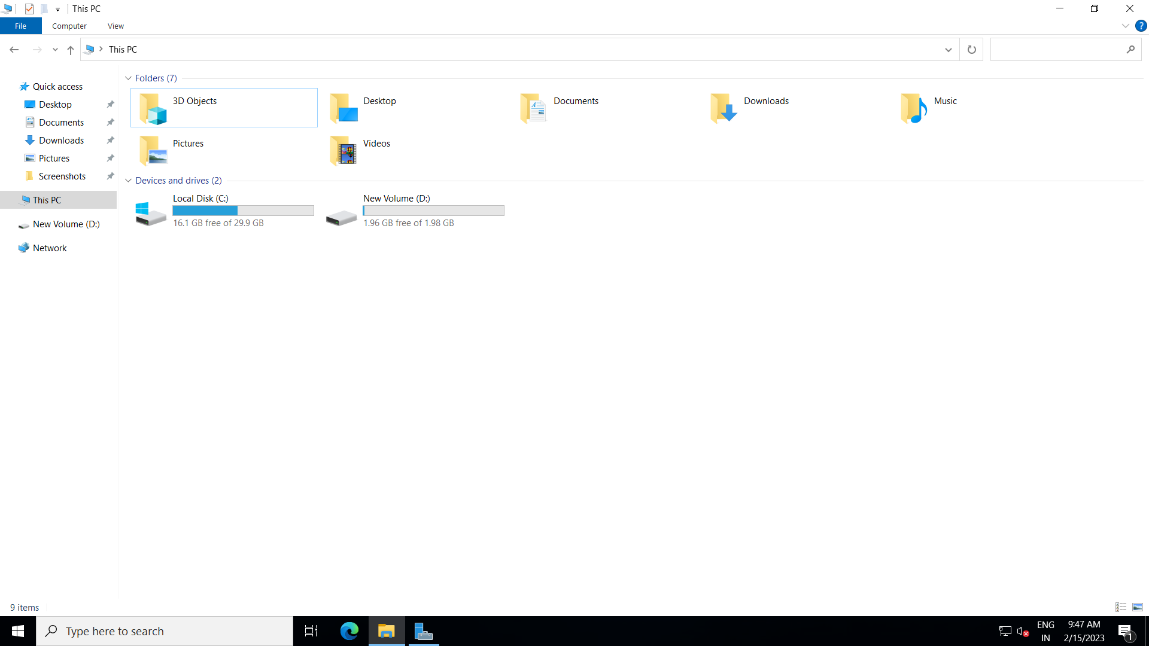

4. Detach the Volume from the Windows Machine.

* Go to ec2 dashboard and select the volumes and then click on actions and select detach volume in aws console ,now windows u should see that volume is removed

